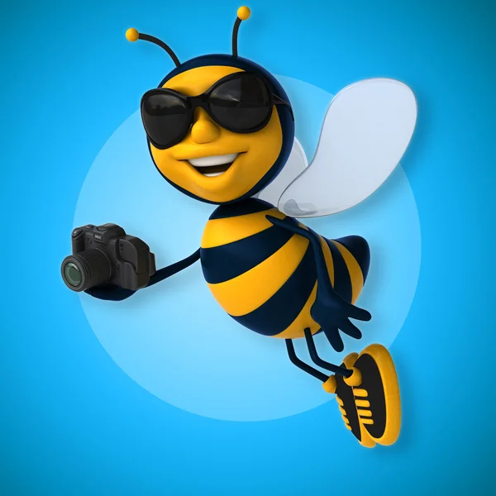
Express Yourself with Photographs

Our World Up Close, Natural Wonders, Reflections,
Volunteers in Action

Contest Rules:
- All photographs MUST be submitted by 9AM of the first day of the Convention.
- All photographers must be dues paying members of an active GFWC Club
- Photos must be taken during the contest year (Jan. 1 – Dec. 31
- NO dates will be allowed on the front of the photo
- Contestants must be amateur photographers – earnings from photography may not exceed $500.00 annually
- Photographs must be original work of the member submitting the photo
- First place photos will not be returned
- Photos may be vertical, portrait or horizontal
- Photos must be submitted directly at the GFWC Ohio Annual Convention in 2023-2024
- The photos may be in black and white or color
- The same image may be submitted to multiple photo categories, but a separate photo must be entered for each category
- Each photograph must be an 8X10 print
- Each photograph must be mounted on a rigid 8X10 inch board and overall thickness may not exceed 3/8 inch. No mats, frames, or hangers are to be included.

Additional Rules for GFWC “Volunteers in Action” Contest
- Photo may be vertical, portrait, or horizontal
- Entries can be either black and white or color photos
- Judges look at overall creativity of subject and quality of photograph
- The same photo may be submitted to multiple categories, but a separate photo must be entered for each category

All entries must include the following information
- Each photo must have a label affixed to its back with the following information:
- Contest Name: World in Pictures with category or GFWC Living the Volunteer Spirit,
- Photographer’s name, email address, mailing address, phone number, name
- Name of state of sponsoring club
- Title and brief caption giving location, date, and other pertinent information about photo
- Arrow indicating the top of the photograph
- Each submission must include a signed GFWC Ohio Creative Arts Waiver

