With my signature I declare that:
 I have created the submitted work, entitled , and I own the full copyright. The work has not been published before.

 With my work, including pictures, tables, or additional media, I do not violate or infringe the copyright of other persons or entities.
The work in question is (check one):  Photography  Poetry  Short Story  Essay  Videography
 I grant the GFWC/Ohio Federation of Women’s Clubs a royalty-free perpetual license to use, reproduce, post, display, create derivative works, sell, license, or sub-license the work in any media now known or later invented without limitation, for commercial or non-commercial purposes.
 I agree that I shall not release the work to any other publication in the same or substantially similar form, without prior written and explicit consent from the GFWC/Ohio Federation of Women’s Clubs.
This agreement shall become effective and binding at the date of formal acceptance of the work for publication by the GFWC/Ohio Federation of Women’s Clubs.

Further, I agree to sign a separate release for the General Federation of Women’s Clubs should my entry be selected to continue to a General Federation of Women’s Club level contest.

Date_________________
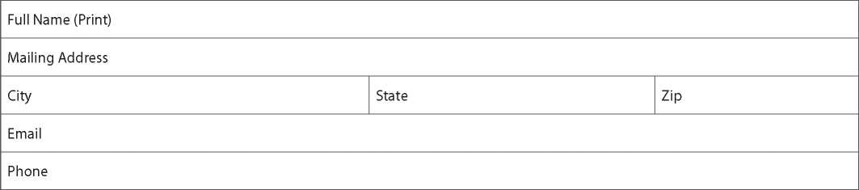
Signature ___________________________________________________

