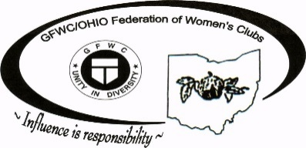
Club Anniversary Order Form
Milestone Anniversaries are as follows: 25,50,60,70, & every 5 years thereafter

Club Name: Click here to enter text.

Anniversary: Click here to enter text.

Federated (Month, Day, Year): Click here to enter text.

Club President’s Name: Click here to enter text.

Club President’s Address: Click here to enter text.
Click here to enter text.

Email Address: Click here to enter text.

Date to be printed on Certificate: Click here to enter text.

Address to be mailed to: Click here to enter text.
Click here to enter text.
Please complete form, then email, or mail to: Marjean Sizemore
172 Jeffrey Street
Wintersville, Ohio 43953
740-264-3474 (home)
740-632-5814 (cell)
sizemore172@comcast.net

GFWC/Ohio Federation of Women's Clubs 2020 – 2022 Administration

