FICTION (by title)
The ALICE NETWORK by Kate Quinn
AMERICAN DIRT by Jeanine Cummins
ANGRY HOUSEWIVES EATING BON BONS by Lorna Landrick
BELGRAVIA by Julian Fellows
The FOUR WINDS by Kristin Hannah
HOLLOW KINGDOM by Kira Jane Buxton
IT ALL COMES BACK TO YOU by Beth Duke
The LOST APOTHECARY by Sarah Penner
NEVER by Ken Follett
The ROSE CODE by Kate Quinn
The SACRIFICE OF LESTER YATES by Robin Yocum
SURVIVING SAVANNAH by Patti Callahan.
The TATTOIST OF AUSCHWITZ by Heather Morris
THESE IS MY WORDS by Nancy E. Turner
28 SUMMERS by Elin Hilderbrand
WHERE THE CRAWDADS SING by Delia Owens
The WOMEN OF CHATEAU LAFAYETTE by Stephanie Dray

NON-FICTION

CHALLENGE THE MOMENT by Michael Kiel
EDUCATED by Tara Westover
HIS PROMISED LAND; an autobiography of John P. Parker, former slave, and conductor on the underground railroad.
IN TIME: THE KILLING OF POLLY PAUL by Paul Petrunak Jr.
The LIFE-CHANGING MAGIC OF TIDYING UP by Marie Kondo
The MAN WHO SAVED THE UNION: ULYSSES GRANT IN WAR AND PEACE BY H. W. Brands
SATURDAY NIGHT WIDOWS BY Becky Aikman
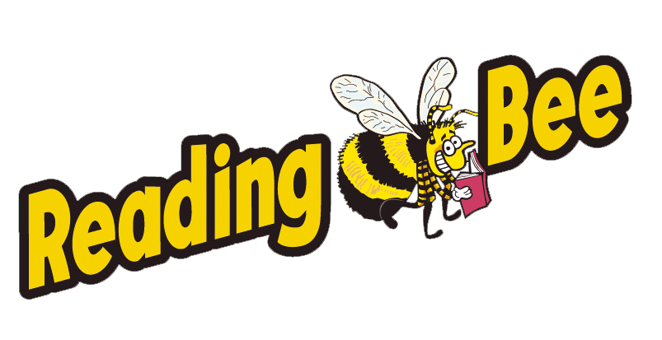
The SECOND CIVIL WAR by Ronald Brownstein

FICTION (by author)

Buxton, Kira Jane – HOLLOW KINGDOM.
Callahan, Patti—SURVIVING SAVANNAH.
Cummins, Jeanine – AMERICAN DIRT.
Dray, Stephanie – THE WOMEN OF CHATEAU LAFAYETTE.
Duke, Beth – IT ALL COMES BACK TO YOU.
Fellows, Julian -- BELGRAVIA.
Follett, Ken – NEVER.
Hannah, Kristin – FOUR WINDS.
Hilderbrand, Elin – 28 SUMMERS.
Landrick, Lorna – ANGRY HOUSEWIVES EATING BON BONS.
Morris, Heather – The TATTOOIST OF AUSCHWITZ.
Owens, Delia – WHERE THE CRAWDADS SING.
Penner, Sarah – The LOST APOTHECARY.
Quinn, Kate – The ALICE NETWORK.
Quinn, Kate – The ROSE CODE.
Turner, Nancy – THESE IS MY WORDS.
Yocum, Robin – The SACRIFICE OF LESTER YATES.

NON-FICTION

HIS PROMISED LAND; an autobiography of John P. Parker, former slave, and conductor on the underground railroad.
Aikman, Becky – SATURDAY NIGHT WIDOWS.
Brands, H. W. – The MAN WHO SAVED THE UNION: ULYSSES GRANT IN WAR AND PEACE.
Brownstein, Ronald – The SECOND CIVIL WAR.
Kiel, Michael – CHALLENGE THE MOMENT.
Kondo, Marie – The LIFE-CHANGING MAGIC OF TIDYING UP.
Petrunak, Jr., Paul – IN TIME: THE KILLING OF POLLY PAUL.
Westover, Tara – EDUCATED.

